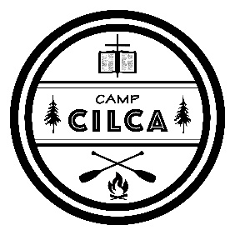
Camp CILCA
Sunday 2020
217-487-7497 / camp@cilca.org /
4124 Camp Cilca Rd, Cantrall, IL 62625

The Central Illinois Lutheran Camp Association (CILCA) set out in 1950 to foster and strengthen faith in Jesus Christ and relationships with others in a unique outdoor setting. Countless volunteers, board members, directors, counselors, and staff members poured effort and time clearing trees, building cabins, and recruiting campers. Now, 70 years later, that mission continues through a vibrant summer camp, family events, and group retreats on 225 acres to explore.

One example of a life touched by Camp CILCA is a young man named Adam. He came to Camp CILCA as a pre-teen who did not take the Christian faith seriously. Weeks spent at CILCA over the course of several years re-oriented Adam to the Word of God. Counselors and fellow campers spoke that Word to Adam through Bible studies, devotions, prayers, and spiritual conversations. The Holy Spirit used these to strengthen Adam’s faith in Jesus Christ. Today, Adam is a Lutheran pastor who shares that same Word of God with his congregation.

The work at Camp CILCA continues for the sake of hundreds of campers like Adam due to the grace and blessing of God our Father. Many of those blessed gifts come through volunteers and donors like you. Will you join hundreds of others in supporting the work of engaging campers with God’s Word in God’s creation?

How can I help?
- Encourage young people to attend CILCA’s summer camp or to volunteer as Junior Counselors.
- Donate financially to the Annual Fund, which provides resources for all CILCA camps, events, and retreats.
- Pray for the staff, counselors, and campers, that the Lord would continue to work in their lives through His Word.
- Volunteer in the kitchen, maintenance, medic or Pastor of the Week.
- Attend annual work days in the spring and fall.
- Attend retreats, events, and fundraisers.
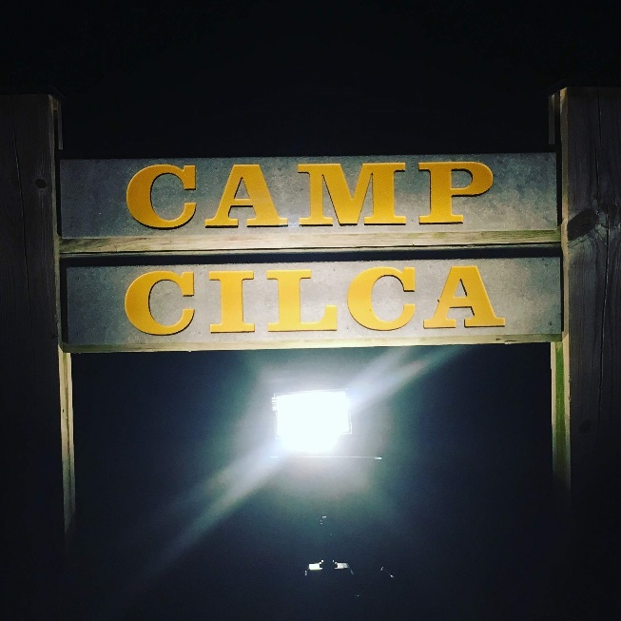
For details about 2020 Summer Camp sessions and other programs and events, visit www.cilca.org or contact Rev. Joshua Theilen, camp executive director.

